Volcanoes: Teacher note
A volcano is an opening in the earth’s surface allowing magma and gases to escape from beneath the surface.
Volcanic activity can be identified and monitored using satellite images to identify volcanoes, hotspots and track ash clouds.
Volcanoes are considered to be active, dormant or extinct.
- An active volcano is one that has erupted in the past 600 years.
- A dormant volcano is one that has not erupted in in the past 600 years but is predicted to erupt again in the future.
- An extinct volcano is one that has not erupted for at least 10 000 years and is not expected to erupt again.
They can remain inactive, or dormant, for hundreds or thousands of years before erupting again. During this time they can become covered by vegetation making them difficult to identify.
Active volcanoes are rare in Australia because there are no plate boundaries on this continent however there is evidence that there have been many volcanoes throughout Australia over the past 60 million years. There are currently no active volcanoes on the Australian mainland. However there are two active volcanoes off Western Australia at Heard Island and McDonald Islands. Heard Island and McDonald Islands are Australian Antarctic Territories.
Volcanic eruptions are classified depending on cloud height and observations. For a volcanic eruption to be classified as a natural disaster, emergency teams consider if it is a single or multiple country event and if the eruption has an effect on communities and public health.
When a volcano erupts, volcanic ash is released into the air and magma from beneath the Earth’s surface is pushed through the main vent causing a crater to form. Once the magma reaches the surface it is called lava, which flows down the side of the volcano until it eventually cools and hardens. Magma can also flow to the surface through other vents in the volcano’s surface.
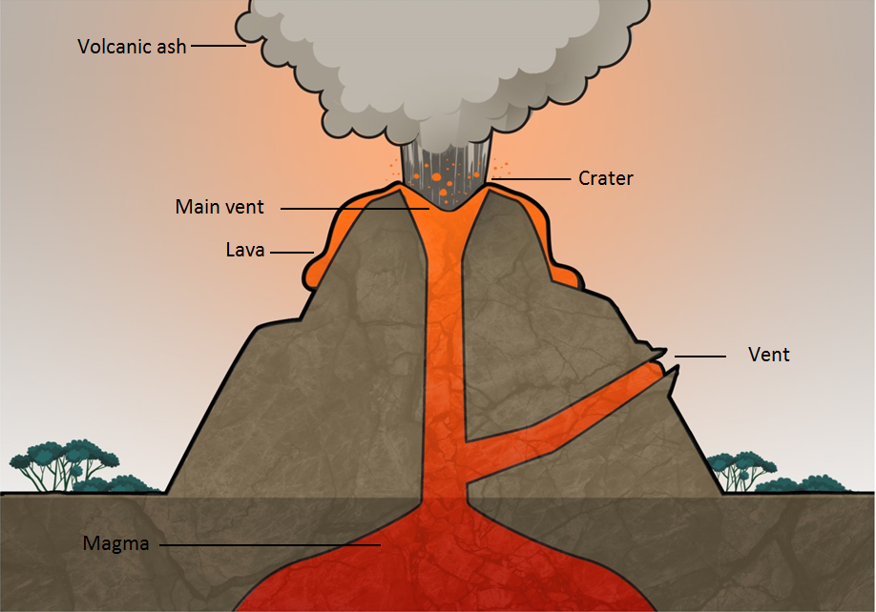

Locating local volcanoes using the internet

Use an internet mapping website to look for Australian volcanoes.

There are three dormant volcanoes on the Australian mainland:
- Mount Schank — South Australia
- Mount Noorat — Victoria
- Mount Fox — Queensland

There are currently two active volcanoes in the Australian Antarctic Territories:
- on Heard Island
- on McDonald Island.

